Should accessibility ever be de-linked from disability?
William – 22 June 2026

Introduction
One time at work, a colleague suggested that I change a Slido quiz answer that read: “Universal design benefits everyone, not just people with disability.” They said this shouldn’t be the primary framing. At the end of the day, universal design is about removing barriers affecting people with disability—when you centre it on anything else, you lose that focus.
I pushed back. I suggested keeping the line because it’s a justification that resonates better with people who don’t have disability. It was consistent with the origins of universal design—the world of physical infrastructure. Kerb cut outs, accessible toilets, and ramps can all be used by people with disability as well as people who don’t have disability.
On reflection, the disagreement wasn't about whether the answer was true. It was about what should take centre stage when we champion universal design—and who gets sidelined when it doesn't.
When I tried to make universal design more appetising, did I de-link disability from accessibility? Should we ever do that?

Other thoughts – What does Reddit think?
In gathering my thoughts, I found two helpful Reddit threads that explored the same tension.
The first one, Thoughts on “accessibility benefits everyone?”, questioned whether accessibility should be viewed through its universality. The upvoted responses suggested the “benefits everyone” framing was a persuasive argument; it was attractive to people in positions of power. This question was asked on the r/disability subreddit, where responses were informed by lived experience of disability.
The second thread, Why is accessibility being de-linked from disability — and what does that say about us?, posted in the r/accessibility subreddit, reflected a more cynical tone.
u/Fragrant-SirPlum98 wrote:
I've literally walked into workplaces with a cane and got told why accessibility didn't matter or it was "too much trouble when we know who uses this".
The threads showed that the disagreement existed not just in a meeting room at my workplace or in an academic journal but was an underlying tension out there.
From what I saw in the two Reddit threads, disability can be de-linked from how we frame accessibility—but in a reluctant, strategic, or resigned way.

The problem with "as shown below”
When we make things accessible, we remove barriers that impact people with disability.
Alt text breaks down communication barriers: if the image has meaningful content, then a person using a screen reader will be able to get that meaning.
Suppose I say: “As shown in the graph below, most screen reader users believe more accessible web sites have more impact on accessibility”.
Did you get any of the meaningful content from that graph?
How about I show you its alt text:
Pie chart showing opinions from screen reader users on improving web accessibility: 85.9% favour making websites more accessible, while 14.1% favour better assistive technology.
You can learn more about the WebAIM’s Screen Reader User Survey #10.
Alt text enables people who use screen readers (predominantly people with vision impairment) to do their job, participate in the community, and feel included. As a blind colleague told me: when you don’t put alt text, you’re effectively telling her that she doesn’t matter.
Accessibility helps people with disability—that should be a strong argument for an organisation that is being responsible.
Unfortunately, not every organisation is like that.

Alt text in Ken and Barbie’s World
A coworker with disability of mine described the perfect individuals as “Ken” and “Barbie”, after the Mattel dolls. For the longest time, these dolls represented a beauty standard that was unattainable. According to my coworker, Ken and Barbie could run a marathon without breaking a sweat.
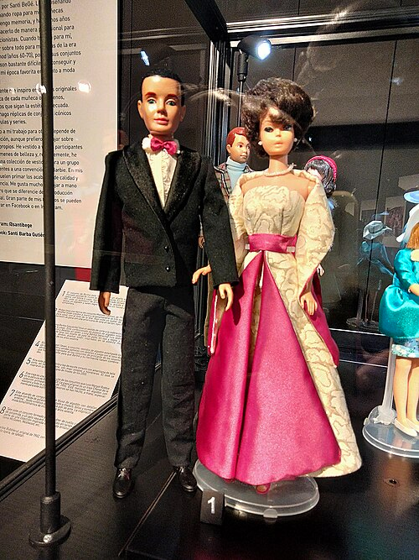
Ken and Barbie displayed in the Textile Museum and Documentation Centre in Terrassa, Catalonia, Spain. Photo by Enric, via Wikimedia Commons, CC BY 4.0.
In Ken and Barbie’s world, would alt text still exist?
Alt text would still exist, but it wouldn’t be called that—maybe it would be known as SEO text. Search engines can’t read images. While current AI models can, it’s a lot faster and less resource-intensive to read text. Alt text would exist for SEO optimisation, and someone with a screen reader in that world will also benefit.
Alt text might also be there for people with slow internet connections—yes, slow internet exists in Ken and Barbie’s world. For the data-conscious, they would load the alt text rather than the image.
Just like that, we de-linked alt text from disability. It’s an argument that works when accessibility has wider benefits than just breaking down barriers for people with disability.

The Cynical Case for Accessibility
Suppose you have to convince a busy senior leader who hasn’t thought a lot about disability. Their understanding of disability is often narrow, and they may carry assumptions about accessibility and its costs.
If they’re the difference between accessibility upgrades to your website, then you need to make it benefit them. You convince them that sufficient colour contrast means they’ll always recognise your brand even when using their phone under a bright light. You tell them that we should adopt Plain English because it’s faster and easier for the senior leaders to read. It saves them time—and it is also less of a load for people with cognitive disabilities.
We need to remember where universal design comes from: the physical world of infrastructure. When you argue for why a ramp should be installed, you need to talk about everyone it will benefit: the parent with a pram, the person with physical disability with the walker, and the tradie dragging a heavy cart. That way, the self-interested senior leader will dedicate the funds needed to make something more accessible.
I call this the “cynical case” because it assumes the key decision-maker is not swayed by “it helps people with disability”. They don’t view disability as part of their work, and that’s an attitude that can be very hard to change.
We assume that people are selfish and can only be convinced to act in the interests of others when it benefits themselves.
It’s a very cynical perspective that many people with disability and accessibility specialists in the Reddit threads have adopted—such is life in an inaccessible world.

Who does accessibility benefit?
Accessibility always benefits people with disability—the people at the heart of accessibility. However, there are different ways you can convince the key decision-maker.
If they care mainly about profits and markets, then accessibility means improved SEO and an untapped market. We should be accessible so that people with disability can access our products and services—and so that organisations do not miss out on their spending power.
If they are new to disability, then accessibility benefits everyone. We should be accessible because if a webpage is accessible for a screen reader user, then it’s likely accessible for everyone else as well.
Both of these arguments de-link disability from accessibility when it comes to justification. We bury the lede, but the barriers still come down.
If they are well-versed in the world of accessibility, disability, and inclusion, then speak plainly: accessibility benefits people with disability. People with disability have the same right to access websites, services, and workplaces as everyone else.
You might have noticed I’ve neglected one argument: the legal one. We should be accessible because we have obligations under the Disability Discrimination Act 1992 (Cth). If something is inaccessible, then we might be discriminating against people with disability. There are plenty of people who follow the law because the cost of non-compliance is too high. Yet legal obligations alone are rarely good enough to persuade people to invest in accessibility. For many, the risk of non-compliance is distant while the cost of making something accessible is immediate.
Accessibility is deeply rooted in disability, but when you need to justify it, you can touch on universality or self-interest. Tailor the message to the audience.
Looking back, my colleague and I were both right. Accessibility benefits everyone, but it has only one origin: disability.
It hurts to cloud disability behind phrases like “benefits everyone”, “spending power”, and “SEO”. However, if we want to remove barriers, then we’ll have to adapt how we persuade others to make things accessible.
It’s a cynical approach, but perhaps it’s what we can expect from an inaccessible world.

